Lab Programs

27. Bar Chart – Programming Language Popularity

AIM
To write a Python program to display a bar chart representing the popularity of different programming languages.

PROCEDURE
- Import matplotlib.pyplot.
- Store the programming language names in a list.
- Store their popularity values in another list.
- Use plt.bar() to create the vertical bar chart.
- Add X-axis and Y-axis labels.
- Add a suitable title.
- Display the chart using plt.show().

CODE
import matplotlib.pyplot as plt

languages = ["Java", "Python", "PHP", "JavaScript", "C#", "C++"]
popularity = [22.2, 17.6, 8.8, 8.7, 7.7, 6.7]

plt.bar(languages, popularity)

plt.xlabel("Languages")
plt.ylabel("Popularity")
plt.title("Popularity of Programming Language")

plt.show()

INPUT
Languages : Java, Python, PHP, JavaScript, C#, C++
Popularity : 22.2, 17.6, 8.8, 8.7, 7.7, 6.7

OUTPUT
A vertical bar chart is displayed showing the popularity of:
Java → 22.2
Python → 17.6
PHP → 8.8
JavaScript → 8.7
C# → 7.7
C++ → 6.7
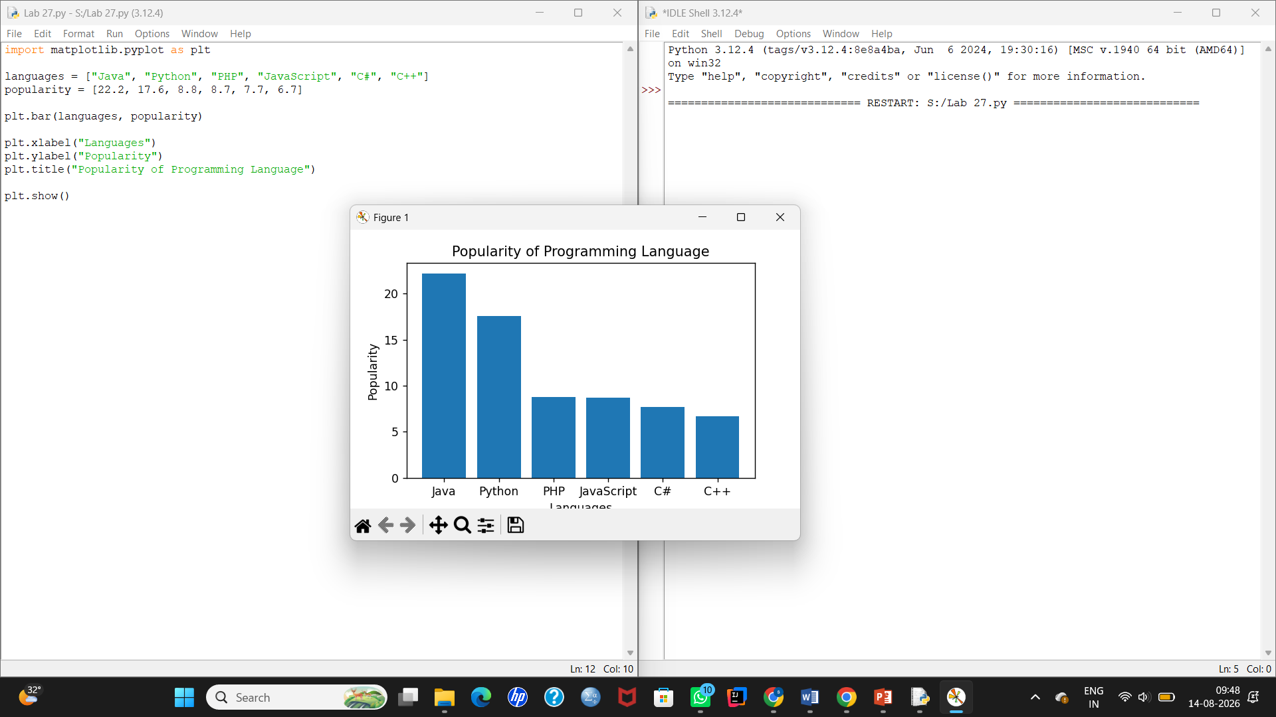

28. Horizontal Bar Chart

AIM
To write a Python program to display a horizontal bar chart representing the popularity of programming languages.

PROCEDURE
- Import matplotlib.pyplot.
- Create lists for languages and popularity.
- Use plt.barh() to create horizontal bars.
- Add suitable X-axis and Y-axis labels.
- Add a title.
- Display the chart.

CODE
import matplotlib.pyplot as plt

languages = ["Java", "Python", "PHP", "JavaScript", "C#", "C++"]
popularity = [22.2, 17.6, 8.8, 8.7, 7.7, 6.7]

plt.barh(languages, popularity)

plt.xlabel("Popularity")
plt.ylabel("Languages")
plt.title("Popularity of Programming Language")

plt.show()

INPUT
Languages : Java, Python, PHP, JavaScript, C#, C++
Popularity : 22.2, 17.6, 8.8, 8.7, 7.7, 6.7

OUTPUT
A horizontal bar chart is displayed with programming languages on the Y-axis and popularity on the X-axis.
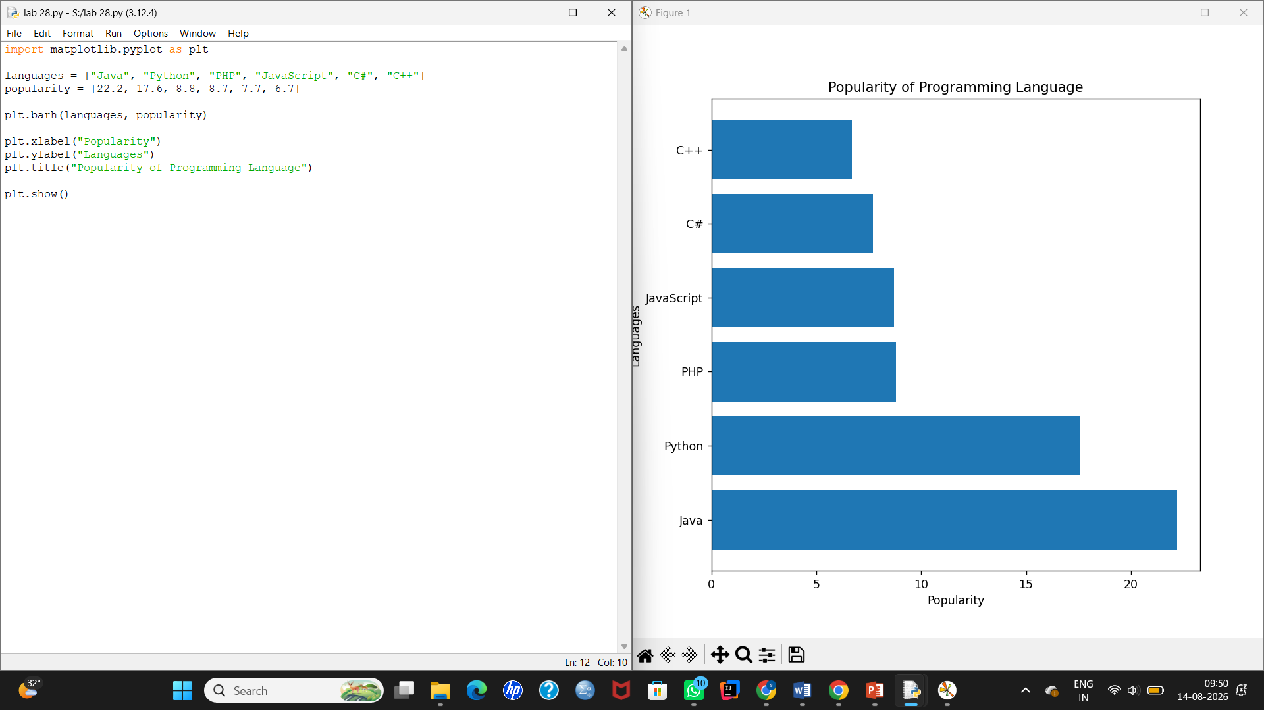

29. Bar Chart with Different Colors

AIM
To write a Python program to display a bar chart of programming language popularity using different colors for each bar.

PROCEDURE
- Import matplotlib.pyplot.
- Store language names and popularity values.
- Create a list containing different colors.
- Use plt.bar() with the color parameter.
- Add axis labels and title.
- Display the chart using plt.show().

CODE
import matplotlib.pyplot as plt

languages = ["Java", "Python", "PHP", "JavaScript", "C#", "C++"]
popularity = [22.2, 17.6, 8.8, 8.7, 7.7, 6.7]

colors = ["red", "black", "green", "blue", "yellow", "cyan"]

plt.bar(languages, popularity, color=colors)

plt.xlabel("Languages")
plt.ylabel("Popularity")
plt.title("Popularity of Programming Language")

plt.show()

INPUT
Languages : Java, Python, PHP, JavaScript, C#, C++
Popularity : 22.2, 17.6, 8.8, 8.7, 7.7, 6.7

Colors:
Java → Red
Python → Black
PHP → Green
JavaScript → Blue
C# → Yellow
C++ → Cyan

OUTPUT
A vertical bar chart with six differently colored bars is displayed:
Java → 22.2
Python → 17.6
PHP → 8.8
JavaScript → 8.7
C# → 7.7
C++ → 6.7
